**Q1**

**Q2**

**Q3**

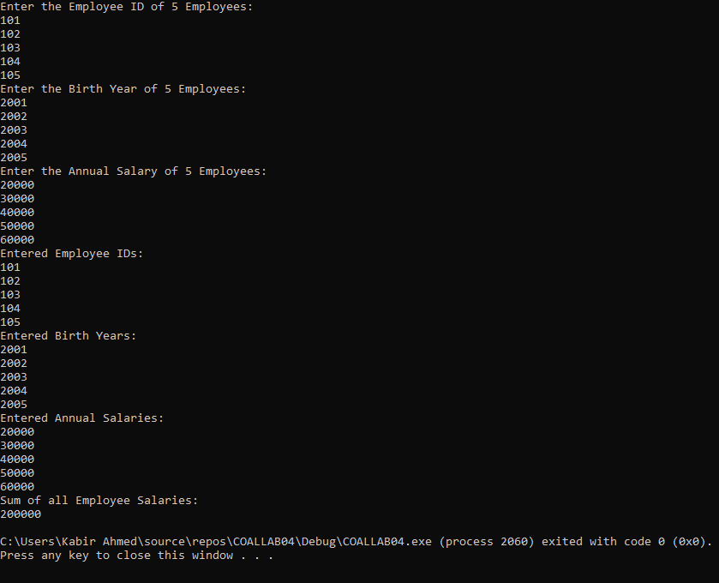

**Q4**

**Q5**

